**Step 1: select krke dekhna padega ki kon kon sa data missing hai**

* **Date & TRN No. Dalna Padta hai**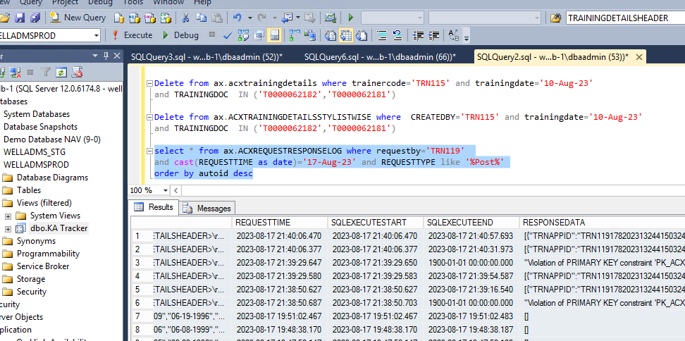

**\*Two Ways How To Find Missing Data**

**1.RESPONSEDATA (Column).**

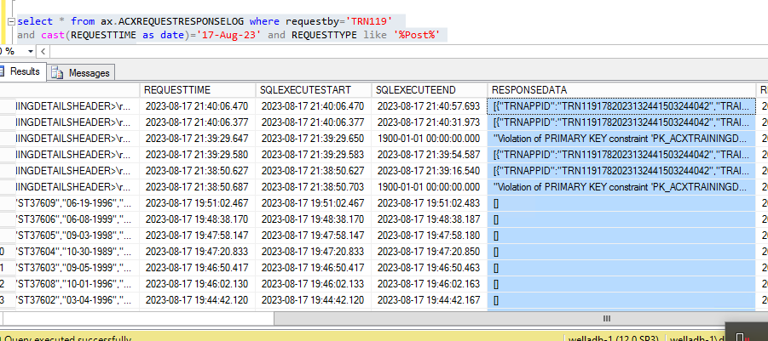

**2.Excel.**

**\* Select all Click Right and Copy with Header will do**

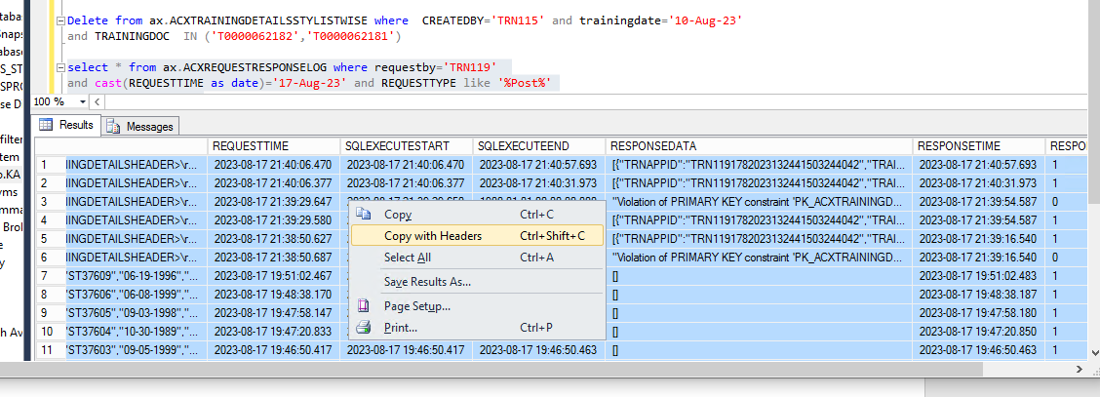

* **Paste in Your Excel File.**
* **Insert 2 column**

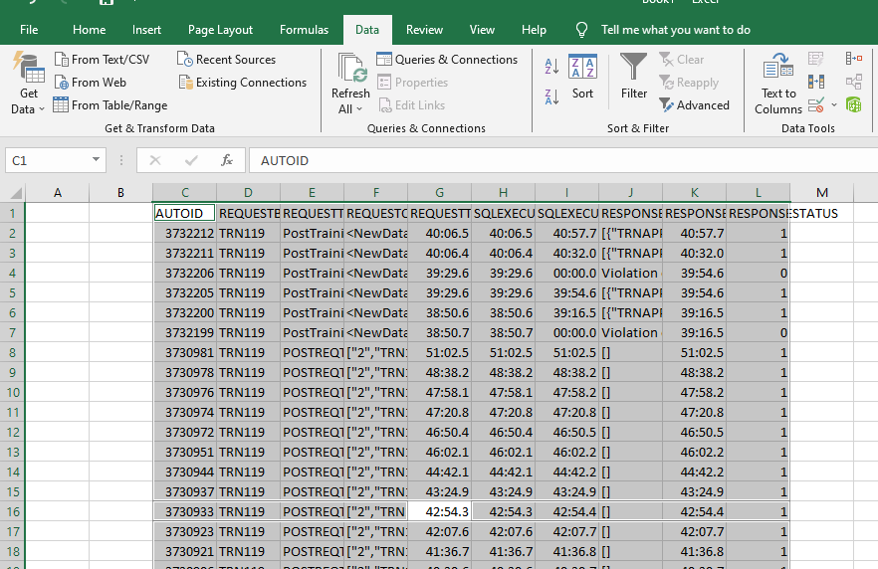

* **Column[b] =len(f2)**
* **Column[a] = MID(F2,60,28)**
* **Drag the bottom**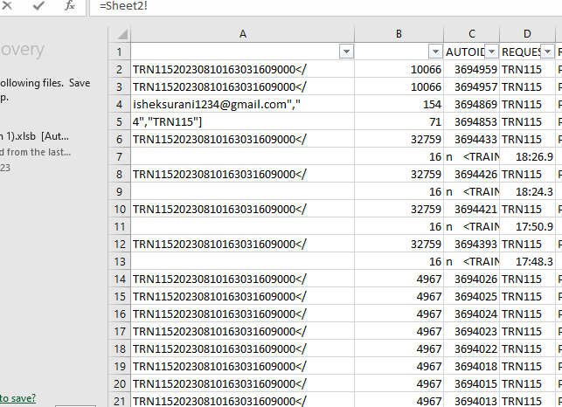

**Check the filter**

**🡺STEP2 :Copy the XML File & paste in your notes.**

**\*Find TRAININGDETAILSHEADER**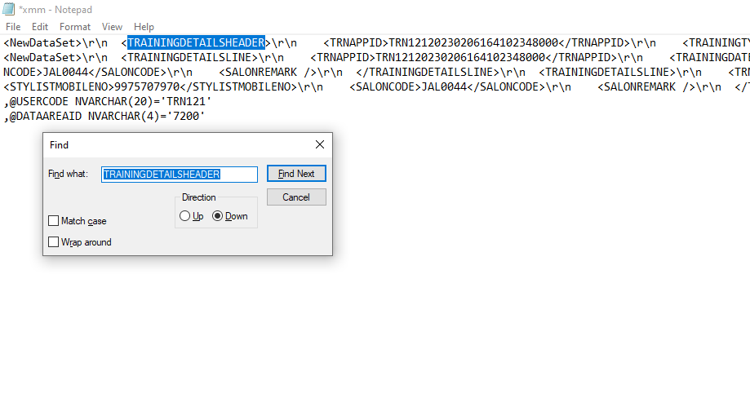

* **Enter 2 times**
* **& press Enter after** ,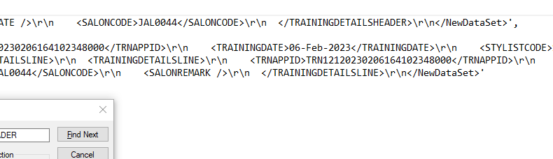
* **Press 1 time serach [TRAININGDETAILSLINE]**

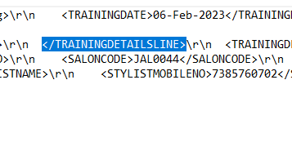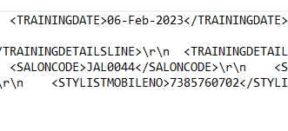

* **Press Enter & Copy[ <NewDataSet>\r\n ]**

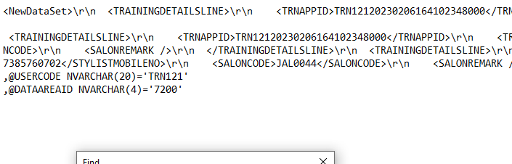

* **Paste in Start**

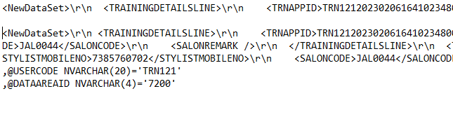

* **Copy** **first line & Third line paste insert Query**

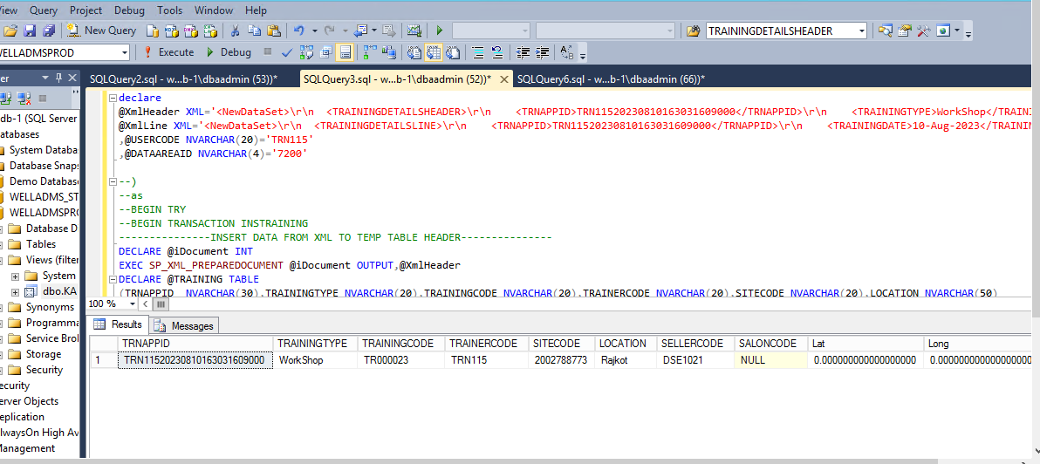

* **After Insert Data query**
* **Go to select Query**
* **& Execute** 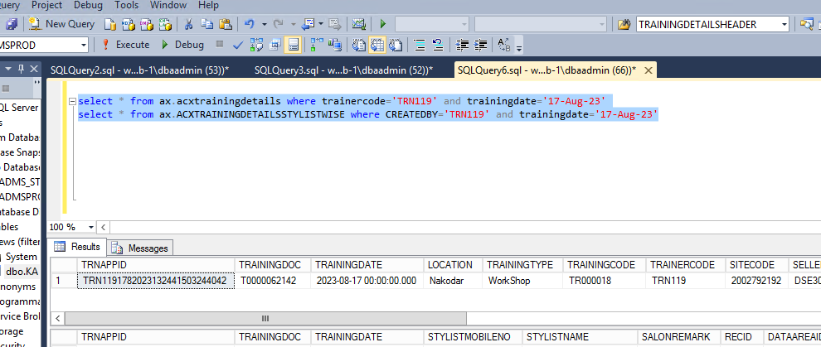
* **Check Header & Line**
* **If Multiple Data will show in Header**
* **Then Delete the data (Line m ho y na ho)**
* **Or header m ho or line m na ho to [Delete the data].**

**\* If Unique data is show {TRAININGDOC & TRAININGCODE}**

**\*Continue.**

**🡺 STEP3: Multiple Data is show**

* **Then delete the data** 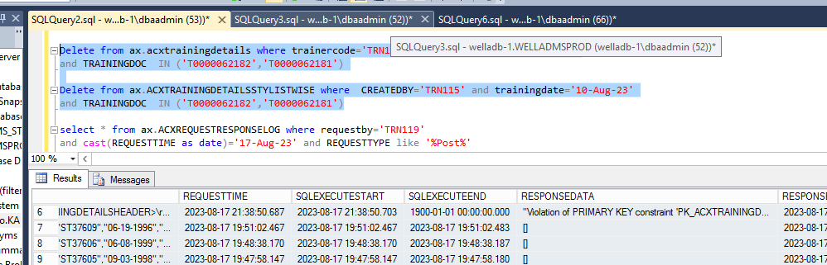
* **Check the select query data is unique or not**

